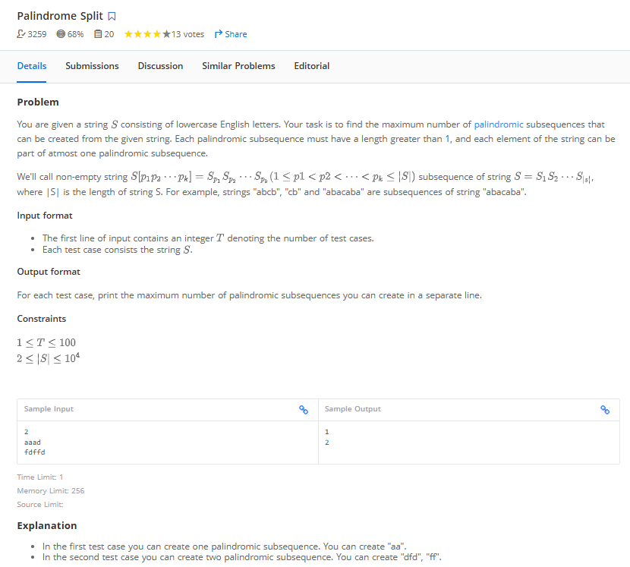

for i in range(int(input())):
#input_strings = list(map(str,input().split(' ')))
input_strings = input().strip()
results = []

freq = {}

#count freq of each char
for ch in input_strings:
freq[ch] = freq.get(ch ,0) +1
#print(freq)

# Calculate maximum number of palindromic subsequences
count = 0
for ch_cnt in freq.values():
count += ch_cnt // 2

results.append(count)
#print(results)

# Print results for all test cases
for result in results:
print(result)

#-----------------------------or
# for i in range(int(input())):
# #input_strings = list(map(str,input().split(' ')))
# input_strings = input().strip()
# results = []

# freq = {}
# for ch in input_strings:
# if ch in freq:
# freq[ch] += 1
# else:
# freq[ch] = 1

# # Calculate maximum number of palindromic subsequences
# count = 0
# for ch_cnt in freq.values():
# count += ch_cnt // 2

# results.append(count)
# #print(results)

# # Print results for all test cases
# for result in results:
# print(result)

